BONFIRE
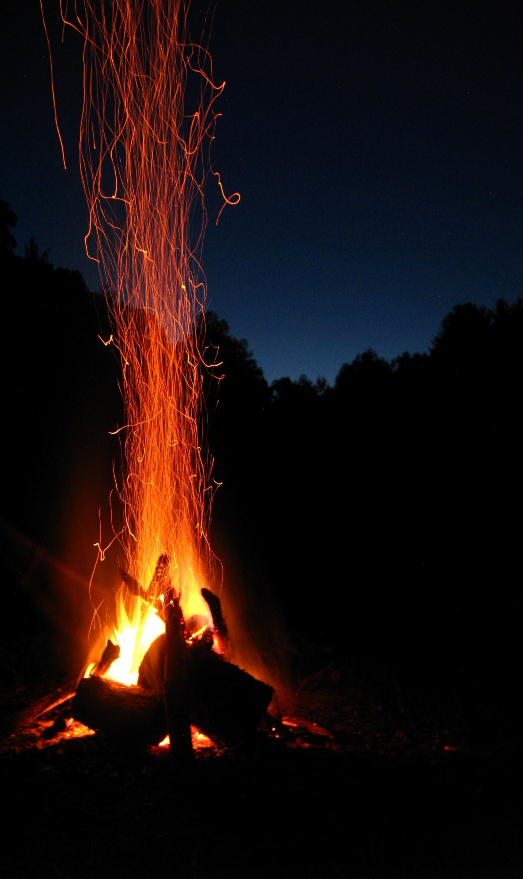
SUNDAY 15th NOVEMBER
************
COME AND JOIN US FROM 4pm
************
WARM YOURSELF BY THE FIRE
************
MULLED WINE
************
BBQ
************
CAKES
*************

